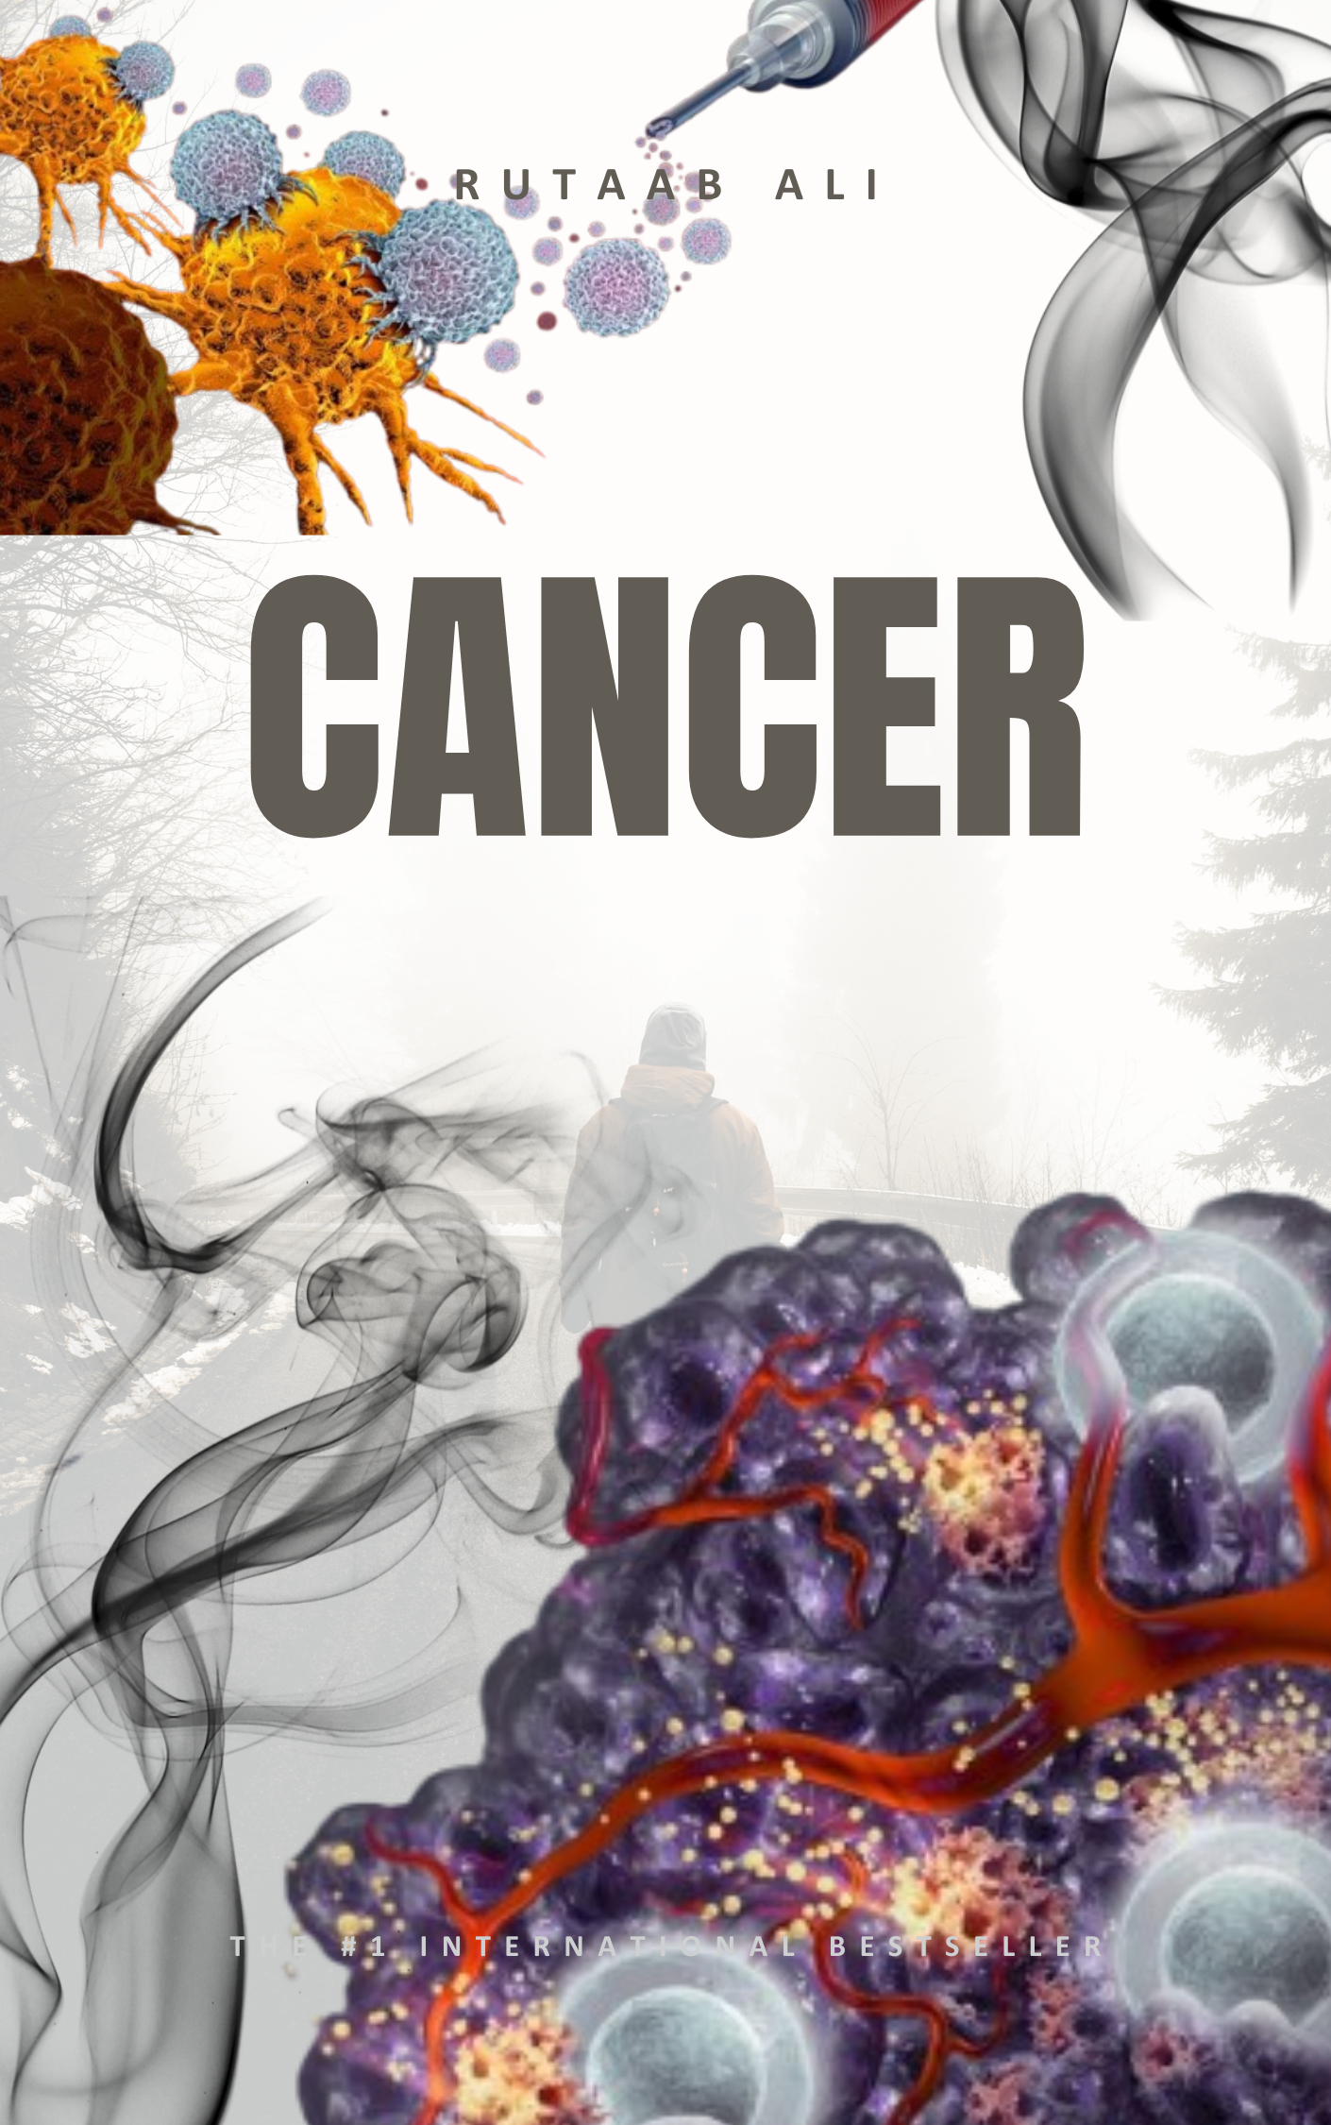
Cancer
I. Introduction to Cancer
Cancer is a complex disease characterized by the uncontrolled growth and spread of the body's cells to other parts of the body. Normally, cells grow, divide, and die in an orderly fashion, but in cancer, this process breaks down, leading to abnormal cells that multiply inappropriately and may form tumors. Cancerous tumors, also known as malignant tumors, can invade nearby tissues and spread to distant sites through a process called metastasis. In contrast, benign tumors usually do not spread or invade nearby tissues, though they can sometimes be large and cause serious symptoms. The study of tumors is known as oncology.
All tumors, both benign and malignant, consist of two basic components:
- Parenchyma: The transformed or neoplastic cells themselves, which dictate the tumor's biological behavior and name.
- Stroma: The supporting, non-neoplastic host-derived tissue, including connective tissue, blood vessels, and inflammatory cells, crucial for tumor growth.
Cancer development is fundamentally a genetic disease, caused by changes to genes that control cell function, growth, and division. These genetic changes can arise from errors during cell division, DNA damage from environmental substances, or inheritance. The body's ability to eliminate cells with damaged DNA decreases with age, contributing to a higher risk of cancer later in life.
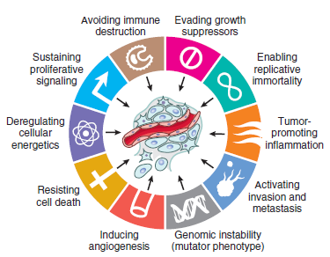
II. Hallmarks of Cancer
The transformation of a normal cell into a tumor cell involves mutations in the cell genome, leading to distinct abnormal characteristics:
- Genome Instability and Mutation: Cancer cells accumulate multiple chromosomal changes (duplications, deletions, rearrangements, point mutations), leading to continual growth.
- Replicative Immortality: Cancer cells exhibit increased telomerase activity, allowing them to divide indefinitely.
- Inducing Angiogenesis: Tumor cells overexpress factors like vascular endothelial growth factor (VEGF) to create a blood supply for nutrients and oxygen.
- Tumor-Promoting Inflammation: Infiltration of tumors by immune system cells can drive tumor growth through inflammatory and angiogenic factors.
- Deregulating Cellular Energetics: Cancer cells modify their metabolism, often increasing glucose uptake and glycolysis for faster growth, even in oxygen-rich environments.
- Evading Growth Suppressors: Cancer cells escape growth-suppressing signals, often due to alterations in tumor-suppressing signaling proteins like p53.
- Resisting Cell Death: Cancer cells bypass programmed cell death (apoptosis), often due to mutations in tumor suppressor proteins like p53.
- Invasion and Metastasis: Tumor cells move from their original site, invading surrounding tissues and spreading via circulatory or lymphatic systems, aided by deregulation of epithelial adhesion molecules.
- Evading Immune Destruction: Tumor cells develop mechanisms to escape surveillance and destruction by the immune system.
III. Fundamentals of Cancer Development
Cancer-causing genetic changes often affect three main types of genes:
- Proto-oncogenes: Normally promote cell growth and division; when altered or overactive, they become oncogenes, leading to uncontrolled cell growth.
- Tumor Suppressor Genes: Normally prevent cancer by slowing or stopping cell growth; inactivating changes in these genes result in uncontrolled cell division.
- DNA Repair Genes: Mutations impair the cell's ability to fix damaged DNA, leading to an accumulation of further mutations and chromosomal changes that contribute to cancer.
IV. Symptoms of Cancer
Cancer symptoms vary widely depending on the type and location of the cancer. Some potential symptoms include:
- Breast Changes: Lump, nipple changes, itchy/red/scaly/dimpled skin.
- Bladder Changes: Trouble urinating, pain during urination, blood in urine.
- Bowel Changes: Blood in stools, changes in bowel habits.
- Cough or Hoarseness: Persistent.
- Eating Problems: Pain after eating (heartburn/indigestion), trouble swallowing, belly pain, nausea/vomiting, appetite changes.
- Fatigue: Severe and persistent.
- Fever or Night Sweats: For no known reason.
- Mouth Changes: White or red patch, bleeding, pain, or numbness in lip/mouth.
- Neurological Problems: Headaches, seizures, vision/hearing changes, facial drooping.
- Skin Changes: Flesh-colored lump that bleeds/turns scaly, new mole or change in existing mole, non-healing sore, jaundice.
- Swelling or Lumps: Anywhere (neck, underarm, stomach, groin).
- Weight Gain or Weight Loss: For no known reason.
V. Etiology of Cancer (Causes and Risk Factors)
Carcinogenic agents cause genetic damage, central to cancer development. They are categorized as:
- Chemical Carcinogens:
- Direct-Acting Agents: Do not require metabolic conversion (e.g., some chemotherapy drugs).
- Indirect-Acting Agents: Require metabolic conversion in the body to become "ultimate carcinogens."
- Radiation Carcinogen: Radiation (UV rays, X-rays, nuclear fission) causes mutagenic effects, leading to chromosome breakage, rearrangements, and point mutations. Double-stranded DNA breaks are the most significant damage.
- Viral and Microbial Carcinogenesis:
- Viruses: Epstein-Barr virus (EBV), Hepatitis B virus (HBV), Hepatitis C virus (HCV), Human Immunodeficiency Virus (HIV), Human Herpes Virus 8 (HHV-8), Human Papillomavirus (HPV), Human T-cell leukemia virus type 1 (HTLV-1). HIV is believed to increase cancer risk by damaging the immune system's defense against other oncoviruses.
- Bacteria: Helicobacter pylori can induce gastric cancer.
Other Factors Influencing Cancer Risk:
- Environmental Exposures: Diet, obesity, smoking (linked to 90% of lung cancer deaths), and alcohol consumption (synergistic effects with smoking).
- Reproductive History: Cumulative exposure to estrogen can increase risk for endometrial and breast cancers.
- Age: Cancer frequency generally increases with age, with most deaths between 55 and 75, due to accumulated somatic mutations and declining immune competence.
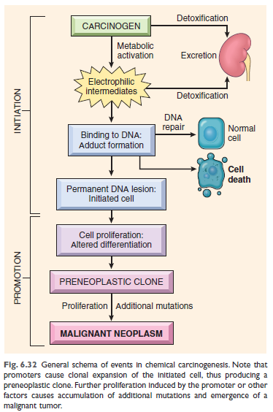
- Diet and Obesity: Implicated as predisposing influences for many cancers.
VI. Acquired Predisposing Conditions
These conditions increase cancer risk, often interacting with genetic factors:
- Chronic Inflammation: Creates a "fertile soil" for malignant tumors, predominantly leading to carcinomas (e.g., chronic hepatitis and hepatocellular carcinoma, inflammatory bowel disease and colon cancer).
- Immunodeficiency States: Increase susceptibility to virus-induced cancers (e.g., specific lymphomas, carcinomas, sarcomas), often seen in HIV patients.
- Precursor Lesions: Localized abnormalities in epithelial differentiation with elevated carcinoma risk, arising from chronic inflammation, hormonal imbalances, or spontaneously. Examples include:
- Squamous metaplasia and dysplasia of bronchial mucosa (in smokers, risk for lung carcinoma).
- Endometrial hyperplasia and dysplasia (from unopposed estrogen, risk for endometrial carcinoma).
- Leukoplakia (oral cavity, vulva, penis, may progress to squamous cell carcinoma).
- Villous adenoma of the colon (high risk for colorectal carcinoma).
Progression of Tissue Changes to Cancer:
- Hyperplasia: Increase in cell number; cells and tissue appear normal.
- Dysplasia: Buildup of abnormal cells with disorganized tissue; higher abnormality correlates with higher cancer chance.
- Carcinoma in situ (CIS): "Stage 0 cancer"; abnormal cells have not invaded nearby tissue. Usually treated due to progression risk.
- Invasive Cancer: Abnormal cells break through the basement membrane and invade nearby tissues or metastasize.
Interaction between Environmental and Genetic Factors: Cancers often result from a combination of environmental conditions and inherited genetic factors. Genetic variations (e.g., in enzymes like cytochrome P-450) can alter risk for environmentally induced cancers. Conversely, environmental factors can influence cancer risk even in individuals with inherited "cancer genes" (e.g., mutated BRCA1/2).
VII. Types of Cancer by Cell Origin
Cancers are named by their organ of origin but also by the specific cell type from which they developed:
- Carcinoma: Most common type, formed from epithelial cells (covering internal and external surfaces).
- Adenocarcinoma: Forms in glandular epithelial cells (e.g., breast, colon, prostate).
- Basal Cell Carcinoma: Begins in the basal layer of the epidermis.
- Squamous Cell Carcinoma: Forms in flat epithelial cells (e.g., skin, lungs, bladder).
- Transitional Cell Carcinoma: Arises in transitional epithelium (e.g., bladder, ureters).
- Sarcoma: Form in bone and soft tissues (muscle, fat, blood vessels, fibrous tissue). Arise from "solid" mesenchymal tissues (e.g., osteosarcoma, liposarcoma).
- Leukemia: Begins in blood-forming tissue of the bone marrow. Do not form solid tumors; abnormal white blood cells accumulate in blood and bone marrow. Classified by progression speed (acute/chronic) and cell type (lymphoblastic/myeloid).
- Lymphoma: Starts in lymphocytes (T or B cells) in lymph nodes, lymph vessels, and other organs.
- Hodgkin Lymphoma: Characterized by Reed-Sternberg cells.
- Non-Hodgkin Lymphoma: Broad category, can be B-cell or T-cell origin.
- Multiple Myeloma: Begins in plasma cells, forming tumors in the bone marrow.
- Melanoma: Starts in melanocytes (pigment-producing cells), usually on the skin but can be in other pigmented tissues (e.g., eye).
- Brain and Spinal Cord Tumors: Named by cell type and location within the central nervous system (e.g., astrocytic tumor). Can be benign or malignant.
- Other Types:
- Germ Cell Tumors: Originate in cells that give rise to sperm or eggs, can be benign or malignant (e.g., teratoma).
- Neuroendocrine Tumors: Form from hormone-releasing cells, can be benign or malignant.
- Carcinoid Tumors: Slow-growing neuroendocrine tumors, usually in the GI system.
Differentiation and Anaplasia: Differentiation refers to how much neoplastic cells resemble their original cells. Anaplasia, or lack of differentiation, is a reliable indicator of malignancy, meaning cells appear very abnormal. Benign neoplasms are typically well-differentiated, while malignant neoplasms vary widely, with undifferentiated (anaplastic) cells appearing abnormal.

VIII. Tumor
A tumor is broadly defined as a "neoplasm, "abnormal mass of tissue, the growth of which exceeds and is uncoordinated with that of the normal tissues and persists in the same excessive manner after cessation of the stimuli which evoked the change". Neoplasms can be either benign (not cancerous) or malignant (cancerous). . The study of tumors is known as oncology.
Components of Tumors: All tumors, benign and malignant, have two basic components:
- Parenchyma: Made up of the transformed or neoplastic cells themselves, which determine the tumor's biological behavior and name.
- Stroma: The supporting, non-neoplastic host-derived tissue, including connective tissue, blood vessels, and inflammatory cells. The stroma is crucial for the neoplasm's growth as it provides blood supply and support.
  - Tumor Microenvironment: Within a tumor, cancer cells are surrounded by a variety of immune cells, fibroblasts, molecules, and blood vessels, forming what is known as the tumor microenvironment. Cancer cells can alter this microenvironment, which in turn influences how the cancer grows and spreads.
I. Benign Tumors
Benign tumors are generally "innocent" and "remain localized."
A. Core Characteristics:
- Nature of Growth: Grow as "cohesive expansile masses that stay at their original sites." They do not "spread into, or invade, nearby tissues."
- Differentiation: Composed of "well-differentiated cells that closely resemble their normal counterparts, both morphologically and functionally." Mitoses (cell divisions) are "usually rare and appear normal."
- Encapsulation: "Typically develop a rim of compressed fibrous tissue, known as a capsule," which makes them "discrete, movable, and often easily removable by surgical enucleation." However, "not all benign neoplasms are encapsulated," such as leiomyoma or hemangiomas.
- Non-metastatic: A "defining characteristic" is that they "do not metastasize," meaning they "do not spread to distant parts of the body." This "unequivocally distinguishes them from malignant tumors."
- Recurrence: "When removed, they usually do not grow back."
B. Nomenclature (Naming Conventions):
Benign tumors are typically named by adding the suffix "-oma" to the cell type of origin.
- -oma: General suffix (e.g., fibroma, chondroma). For example, a benign tumor from fibrous tissue is a fibroma, and one from cartilage is a chondroma.
  - Adenoma: Benign epithelial neoplasms forming or derived from gland-like structures.
  - Papillomas: Benign epithelial neoplasms producing "finger-like fronds" on surfaces.
  - Polyp: A mass "projecting above a mucosal surface."
  - Mixed Tumors: Result from "divergent differentiation" from a single progenitor cell.
  - Fibroadenoma: Common benign breast tumor with proliferating ductal elements in fibrous tissue (only fibrous component is neoplastic).
  - Teratoma: A "special type of mixed tumor" containing mature or immature cells/tissues "derived from more than one germ cell layer, sometimes all three," originating from totipotential germ cells.
III. Malignant Tumors (Cancerous)
Malignant tumors, or cancer, are defined by their "uncontrolled growth" and ability to "invade and destroy adjacent structures and spread to distant sites (metastasize), potentially causing death."
A. Core Characteristics:
- Uncontrolled Growth and Spread: Cancer cells "grow uncontrollably and spread to other parts of the body." They are "invasive" (damaging surrounding tissues) and "metastatic" (traveling to distant locations).
- Recurrence: "Unlike benign tumors that usually do not grow back when removed, cancerous tumors sometimes do."
- Differentiation and Anaplasia:
  - Differentiation: Malignant neoplasms show a wide range, but "many exhibit morphological alterations that indicate their malignant nature."
  - Anaplasia: Means "to form backward" or "lack of differentiation." Tumors composed of "undifferentiated cells are said to be anaplastic, which is a reliable indicator of malignancy." This signifies "a loss of the structural and functional differentiation of normal cells."
- Morphological Changes in Anaplastic Cells: Significant abnormalities under a microscope include:
  - Pleomorphism: Variation in cell and nuclear size/shape.
  - Abnormal Nuclear Morphology: Nuclei are often "hyperchromatic," with an "increased nucleus-to-cytoplasmic ratio (changing from normal 1:4 or 1:6 to 1:1)," irregular shapes, and large nucleoli.
  - Mitoses: "High numbers of mitotic figures are present, often atypical and bizarre."
  - Loss of Polarity: Cells show "disorganized or anarchic arrangement."
  - Lack of Encapsulation: Cancers "lack well-defined capsules." Their growth is characterized by "progressive infiltration, invasion, and destruction of surrounding tissues," often appearing with "crablike feet" microscopically.
B. Nomenclature:
Malignant tumors are collectively called cancers.
- Sarcomas: Arise from "solid" mesenchymal tissues (e.g., liposarcoma, chondrosarcoma).
- Carcinomas: Arise from epithelial cells (e.g., renal cell adenocarcinoma, squamous cell carcinoma). Can be adenocarcinomas or squamous cell carcinomas.
- Leukemias and Lymphomas: Originate from mesenchymal cells of blood or lymphocytes; "generally do not form solid tumors."
- Multiple Myeloma: Starts in plasma cells, forming bone tumors.
- Melanoma: Originates in melanocytes.
- Brain and Spinal Cord Tumors: Named by cell type and location.
- Special Types: Germ Cell Tumors and Neuroendocrine Tumors can be benign or malignant.
- "Mixed Tumors" and Teratomas: Similar to benign counterparts, but can be malignant (e.g., malignant teratomas).
C. Behavioral Differences (Hallmarks of Cancer):
Cancer cells exhibit several distinct "hallmarks":
- Uncontrolled growth, ignoring normal growth signals and signals to stop dividing/die (apoptosis).
- Ability to "invade nearby areas and spread (metastasize) to distant parts of the body."
- Induce angiogenesis (new blood vessel growth).
- Ability to "hide from or manipulate the immune system."
- Accumulate "multiple genetic changes" leading to "genome instability and mutation."
- Exhibit "replicative immortality" (dividing indefinitely).
- Deregulation of cellular energetics, relying on different nutrients for faster growth.
- May exhibit "tumor-promoting inflammation."
Characteristics Distinguishing Benign and Malignant Tumors
Three fundamental features distinguish benign and malignant tumors:
- Differentiation and Anaplasia:
- Benign Neoplasms: Well-differentiated cells, closely resembling normal counterparts. Mitoses are rare and normal.
- Malignant Neoplasms: Wide range of differentiation; many show morphological alterations. Anaplasia (lack of differentiation) indicates malignancy.
- Morphological Changes in Anaplastic Cells: Pleomorphism (variation in size/shape), abnormal nuclear morphology (hyperchromatic, irregular, high nucleus-to-cytoplasm ratio), high number of atypical mitoses, loss of polarity (disorganized arrangement).
- Local Invasion:
- Malignant Tumors: Characterized by progressive infiltration, invasion, and destruction of surrounding tissues. Typically lack well-defined capsules. Microscopically show "crablike feet" penetrating adjacent structures.
- Benign Tumors: Grow as cohesive, expansile masses, localized to origin, often encapsulated by compressed fibrous tissue, making them easily removable.
- Metastasis:
- Malignant Tumors: Defined by the spread of tumor to physically discontinuous sites. Benign neoplasms do not metastasize.
- Pathways of Dissemination:
  - Seeding within Body Cavities: Neoplasms invade natural body cavities (e.g., ovarian cancer in peritoneal surfaces).
  - Lymphatic Spread: More typical of carcinomas; involves regional lymph nodes, can "skip" nodes.
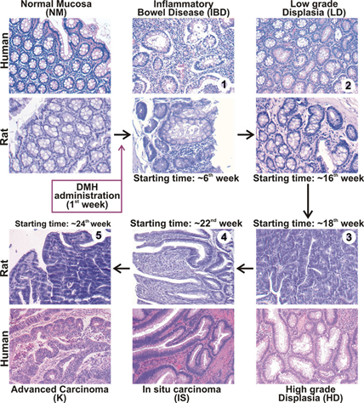
  - Hematogenous Spread: Favored by sarcomas, but also by carcinomas. Veins are more commonly penetrated. Liver and lungs are most frequent secondary sites due to blood flow.
Progression of Tissue Changes to Cancer:
Not all abnormal tissue changes are cancerous, but some can progress to cancer if untreated.
- Hyperplasia: Cells multiply faster, but morphology and organization remain normal.
- Dysplasia: Accumulation of abnormal cells with altered tissue organization. The more abnormal, the higher the cancer risk.
- Carcinoma in situ (CIS): "Stage 0 cancer," where abnormal cells "have not invaded nearby tissue." Usually treated due to potential progression.
- Invasive Cancer: Abnormal cells "break through the basement membrane and invade nearby tissues and structures, or spread to distant sites (metastasize)." This is definitively classified as cancer.
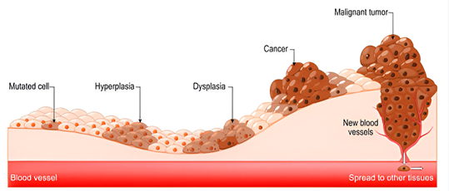

IX. Cancer Staging and Prognosis
Cancer Staging: Defines the extent of cancer within the body, helping determine seriousness, estimate survival, and plan treatment. The stage assigned at diagnosis remains consistent.
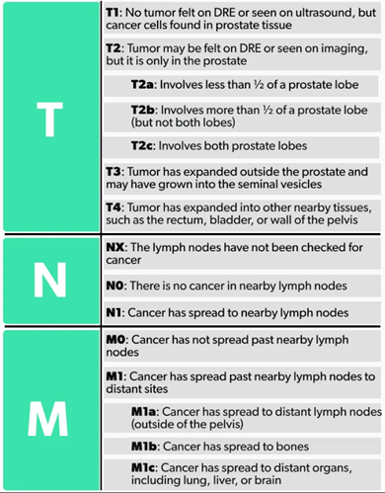
- How Stage is Determined: Doctors use X-rays, lab tests, and biopsies. A pathologist examines tissue samples.
- TNM Staging System: Most common system, assessing:
  - T (Tumor): Size and extent of the primary tumor (T0-T4, TX). Higher number means larger/more extensive.
  - N (Nodes): Number of nearby lymph nodes containing cancer (N0-N3, NX). Higher number means more involved nodes.
  - M (Metastasis): Whether cancer has spread to distant parts of the body (M0 - no spread, M1 - has spread, MX).
- Grouped Stages (0-IV):
  - Stage 0: Abnormal cells present but not spread; Carcinoma in situ (CIS).
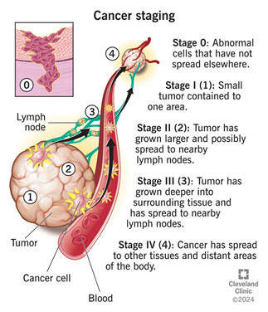
  - Stage I, II, III: Cancer present; higher number indicates larger tumor and greater spread into nearby tissues.
  - Stage IV: Cancer has spread to distant parts of the body (M1).
Prognosis: An estimate of how the disease will likely progress for an individual. Influenced by stage, type, location, grade, genetic changes, patient's age/health, and treatment response.
- Prognosis vs. Tumor Grade:
  - Cancer Stage: How large the tumor is and how far it has spread.
  - Tumor Grade: How abnormal cancer cells look under a microscope, indicating how quickly the cancer is likely to grow and spread.
    - Well-differentiated (low grade): Cells look more normal, less aggressive.
    - Poorly differentiated or undifferentiated (high grade): Cells look less normal, more aggressive.
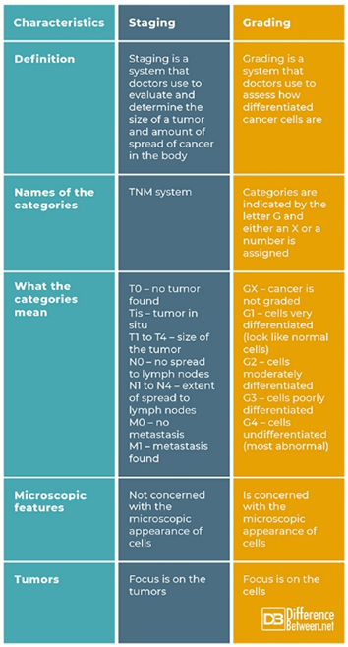
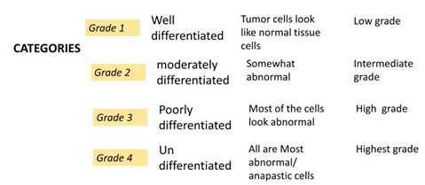
    - Grading Scale: Grade X (undetermined) to Grade 4 (undifferentiated).

Survival Statistics:
- Cancer-specific survival: % not died from cancer within a period.
- Relative survival: % survived compared to people without cancer.
- Overall survival: % not died from any cause within a period.
- Disease-free survival: % showing no signs of cancer after treatment.
Cure vs. Remission:
- Remission: Signs and symptoms of cancer are reduced (partial or complete).
- Cure: No traces of cancer after treatment, and it will never return. Doctors typically say "no signs of cancer at this time" due to the chance of recurrence.

X. Key Diagnostic Tools and Procedures
Doctors use various tests to diagnose cancer:
- Lab Tests: Measure substances in body fluids; used with other tests for diagnosis.
- Blood Chemistry Tests: Organ function indicators.
- Complete Blood Count (CBC): Blood cell counts; diagnoses leukemias, monitors treatment.
- Cytogenetic Analysis: Detects chromosome changes (broken, missing, rearranged, extra).
- Immunophenotyping: Identifies cells by surface markers; diagnoses blood cancers.
- Liquid Biopsy: Blood test for cancer cells or tumor DNA; early detection, treatment planning, recurrence monitoring.
- Sputum Cytology: Examines lung mucus for abnormal cells.
- Tumor Marker Tests: Measure substances produced by cancer cells or in response to cancer (proteins, genomic mutations); indicate aggressiveness, treatment response, recurrence.
- Urinalysis and Urine Cytology: Examine urine for abnormal cells; diagnoses kidney, bladder, and urothelial cancers.
- Imaging Tests: Create pictures of internal body areas.
- CT scan: Detailed 3-D images using X-rays.
- MRI: Detailed images using magnets and radio waves.
- Nuclear Scans (Radionuclide Scans): Involve radioactive tracer (e.g., Bone Scan, PET scan). PET scans detect areas of high glucose uptake by cancer cells.
- Ultrasound: Uses high-energy sound waves.
- X-rays: Low-dose radiation for internal images.
- Biopsy: Often the only definitive way to confirm a cancer diagnosis. A pathologist examines a tissue sample.
- Needle Biopsy: Uses a needle to withdraw tissue/fluid (e.g., bone marrow, organ biopsies).
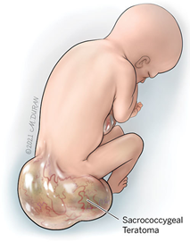
- Endoscopy: Lighted tube inserted to visualize and sample internal areas (e.g., colonoscopy, bronchoscopy).
- Surgery: Removal of part or all of abnormal cells.
- Excisional Biopsy: Entire abnormal area removed with margin.
- Incisional Biopsy: Only part of abnormal area removed.
- Sentinel Lymph Node Biopsy: Checks nearby lymph nodes for spread.
- Bodily Fluids: Examination of cells from urine, cerebrospinal fluid, sputum, etc.
Key Concepts in Pathology Reports:
- Lymph Node Status: Positive (contain cancer) or negative (no cancer).
- Margins: Edges of removed tissue. Positive/Involved margins mean cancer cells are found at the edge, suggesting incomplete removal. Negative/Clean margins mean no cancer cells are found.

Types of Blood Cancer
There are three primary types of blood cancer: Leukemia, Lymphoma, and Myeloma.

1. Leukemia
Leukemia is a cancer of the blood cells, primarily affecting white blood cells (WBCs), which are crucial for fighting infections. In leukemia, the DNA in cells mutates, leading to the production of a large number of immature WBCs called blasts. These abnormal cells gradually take over the function of the bone marrow.
- Epidemiology:
  - Leukemia is the most common cancer in children, especially acute lymphoblastic leukemia (ALL), with peak incidence between ages 2 and 9. It is the second most common cancer in infants.
  - More than 90% of all leukemias are diagnosed in adults.
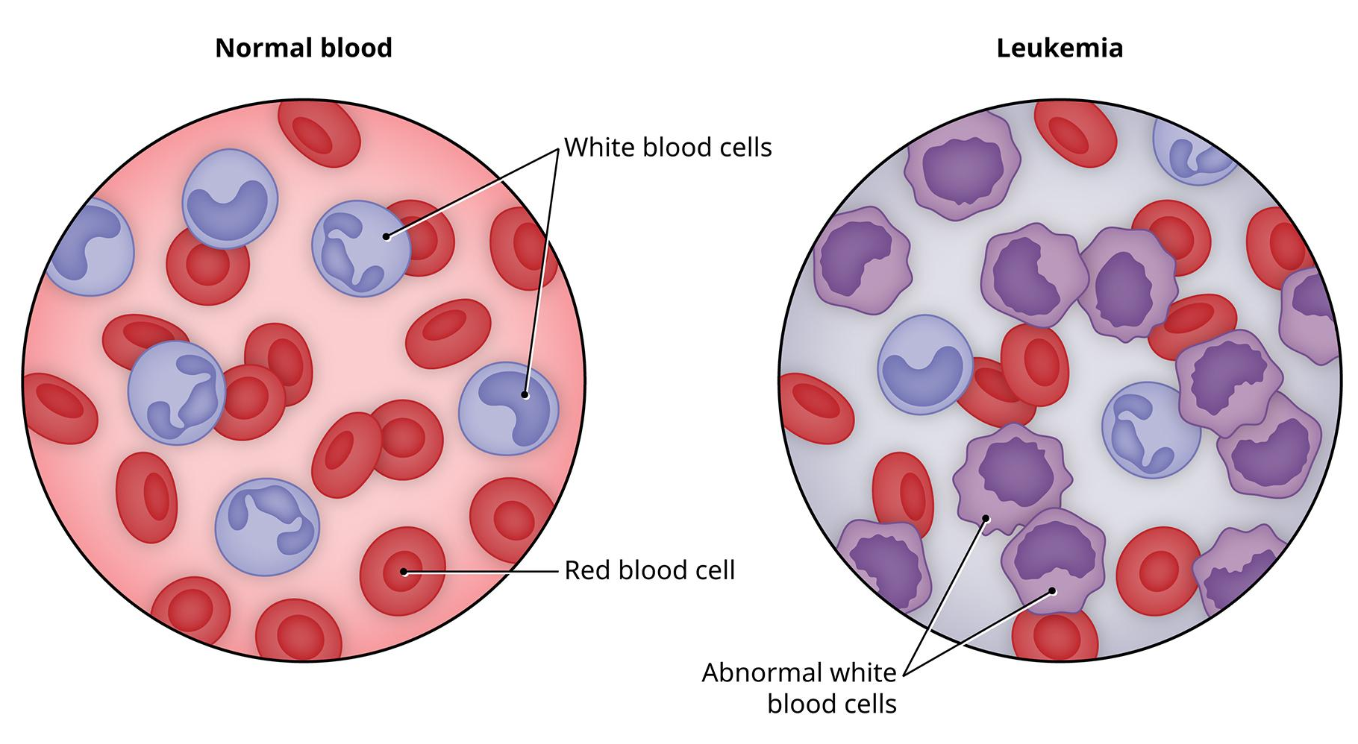
- Causes: The specific cause is often unknown, and different leukemias likely have different causes.
  - DNA mutations that activate oncogenes or deactivate tumor suppressor genes, disrupting cell regulation, can trigger leukemia. These mutations can be spontaneous or result from exposure to radiation or carcinogens.
  - Natural and artificial ionizing radiation.
  - Viruses, such as human T-lymphotropic virus (HTLV-1), are known to cause adult T-cell leukemia.
  - Chemicals, notably benzene and alkylating chemotherapy agents. Exposure to petrochemicals and hair dyes has also been linked.
  - Tobacco use is associated with a small increased risk of acute myeloid leukemia (AML) in adults.
  - Genetic predisposition, chromosomal abnormalities, and genetic conditions like Down syndrome and Fanconi anemia.
  - Rare cases of maternal-fetal transmission have been reported.
  - Diet has very limited or no effect, though eating more vegetables may offer a small protective benefit.
- Types of Leukemia:
  - Acute Lymphocytic Leukemia (ALL): Affects lymphocytes, producing large numbers of immature lymphocytes that hinder bone marrow function. Causes can include exposure to toxins like benzene and radiation, chemotherapy, and chromosomal abnormality. It is the most common cancer in children.
  - Acute Myelogenous Leukemia (AML): Develops from immature cells in the bone marrow that would have become white blood cells. Caused by exposure to harmful chemicals and rays, blood disorders, or a weakened immune system. It progresses rapidly and is the most common acute leukemia in adults.
  - Chronic Lymphocytic Leukemia (CLL): A slow increase in lymphocytes, affecting lymph nodes and the spleen, eventually causing bone marrow failure. Its reason is unknown and not linked to radiation, though exposure to Agent Orange during the Vietnam War increased risk.
  - Chronic Myelogenous Leukemia (CML): A slow build-up of immature white blood cells. It is related to the presence of an abnormal chromosome called the Philadelphia chromosome, and radiation exposure may also be a cause.
  - Hairy Cell Leukemia (HCL): A rare type affecting white blood cells that appear "hairy" under a microscope. The cause is unknown.
- Pathophysiology: Leukemia involves malignant neoplasms of cells derived from myeloid or lymphoid hematopoietic stem cells in the bone marrow. Proliferating abnormal and immature cells (blasts) enter the blood and infiltrate the spleen, lymph nodes, and other tissues. Acute leukemias progress rapidly, with high numbers of circulating blasts weakening blood vessel walls, leading to a high risk of rupture and bleeding, including intracranial hemorrhage.
- Diagnosis:
  - Typically based on repeated complete blood counts and a bone marrow examination following symptom observation.
  - A lymph node biopsy may be performed for certain types.
  - Blood chemistry tests determine liver and kidney damage or chemotherapy effects.
  - X-rays, MRI, or ultrasound can view leukemia's effects on bones, brain, kidneys, spleen, and liver. CT scans are rarely used for chest lymph nodes.
  - Mutation in the SPRED1 gene, associated with childhood leukemia, can be diagnosed with genetic sequencing.
- Treatment: Depends on the type of leukemia, general physical health, age, and stage.
  - Chemotherapy: The most widely used treatment, occurring in three stages:
    - Induction: Kills off abnormal cells in the blood.
    - Consolidation: Destroys abnormal cells not visible in regular blood tests.
    - Maintenance: Used for ALL to prevent regrowth of leukemia cells.
    - If leukemia spreads to the brain or spinal cord, intrathecal chemotherapy (direct injection) is used.
  - Radiation Therapy: High doses of direct radiation aimed at cancer cells to induce remission.
  - Stem Cell Transplantation: Used in severe cases, involving the destruction of infected bone marrow and replacement with healthy stem cells from a matched donor.

2. Lymphoma
Lymphoma is a family of blood cancers arising from cancerous lymphocytes (B-cells, T-cells, and NK-cells). Lymphocytes are white blood cells that normally fight infections and travel within the lymphatic system, which includes lymph nodes, spleen, thymus, and tonsils. Lymphoma often grows in lymph nodes (nodal sites) or outside them (extranodal sites). With timely intervention, certain types can be completely cured.
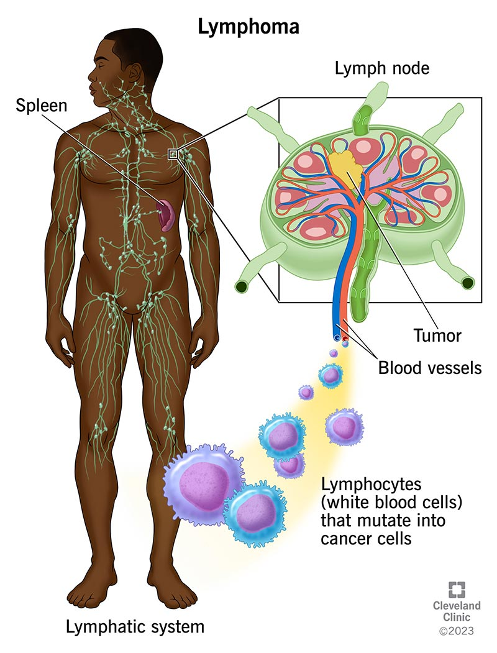
- How Common is Lymphoma:
  - In the UK, lymphoma is the fifth most common cancer.
  - Hodgkin and non-Hodgkin lymphoma affect both genders, all ages, and all races.
- Risk Factors:
  - Age and Gender: Hodgkin lymphoma is more common in teens (peak between 15 and 29) and over 60. It is slightly more common in men than women. NHL risk increases with age, most commonly diagnosed in people over 55, and affects slightly more men than women.
  - Previous Non-Hodgkin Lymphoma: Treatment for a previous NHL can increase the risk of Hodgkin lymphoma.
  - Lowered Immunity: Individuals with impaired immune systems (e.g., HIV/AIDS, organ transplant recipients on immunosuppressants) have a significantly higher risk of both Hodgkin and Non-Hodgkin lymphoma.
  - Autoimmune Conditions: Conditions like systemic lupus erythematosus (SLE), and rheumatoid arthritis are associated with increased NHL risk.
  - Infections:
    - Epstein-Barr virus (EBV): Causes glandular fever and is associated with increased risk of Hodgkin lymphoma and certain NHL subtypes.
    - Hepatitis C virus (HCV): May increase risk of Hodgkin lymphoma and NHL.
    - Hepatitis B virus (HBV): Appears related to increased NHL risk.
    - Helicobacter pylori: Associated with gastric NHL.
    - Human herpes virus 6.
  - Family History: First-degree relatives of Hodgkin lymphoma patients have an increased risk. Identical twins of diagnosed patients are almost 100 times more likely to develop it.
  - Lifestyle: A few studies show a lower risk of Hodgkin lymphoma in alcohol drinkers, but not in drinkers who smoked. Being very overweight (obese) has shown an increased risk for men. Breastfeeding may lower the risk of Hodgkin lymphoma in children.
- Types of Lymphoma: There are two main types and many subtypes (over 80 types).
  - Hodgkin Lymphoma (HL): Characterized by presence of specific type of large abnormal cells called Reed-Sternberg cells. Cancer of the lymph tissue found in the spleen, lymph nodes, bone marrow, etc. Its cause is unknown, but prior HIV or EBV infection increases risk. Affects primarily people aged 15-34 or over 60.
  - Non-Hodgkin Lymphoma (NHL): Cancer of the B or T lymphocytes in lymph tissues. Its cause is unknown, but it develops in people with weakened immune systems, prior HIV infection, or after organ transplantation. NHL is generally more common than HL and increases with age. It is classified as:
    - Low-grade (indolent): Slow-growing, often incurable, more common in the elderly, and may not require immediate treatment.
    - High-grade (aggressive): Fast-growing, potentially curable, occurs in all age groups, and treatment often starts soon after diagnosis.
    - B-cell NHL: Much more common, developing from B lymphocytes. Examples include Diffuse Large B-cell Lymphoma (DLBCL) (30% of cases), Follicular Lymphoma (25%), Small Lymphocytic Lymphoma (7%), Mantle Cell Lymphoma (6%), and Burkitt Lymphoma (2.5%).
    - T-cell NHL: Less common, developing from T lymphocytes.
  - Burkitt Lymphoma: A rare type, mostly observed in African children and more common in males. In Africa, it's linked to EBV, but not in the USA. Weakened immune system increases risk.
- Pathophysiology: Lymphoma starts when a lymphocyte changes into an abnormal cell that divides uncontrollably, often forming masses (tumors) in lymph nodes and elsewhere. It can spread to almost any tissue or organ. B cells are particularly prone to malignant transformation due to the machinery used for antibody diversification, which can cause chromosomal translocations and oncogenic mutations.
- Ann Arbor Staging: Classifies lymphoma into stages I through IV, based on the location and spread of the disease.
- B Symptoms: A classic triad of symptoms that doctors consider for treatment planning:
  - Unexplained weight loss (more than 10% of body weight).
  - Drenching night sweats.
  - Fevers (temperatures above 38°C or 100.4°F). Other symptoms include itching and pain with alcohol intake.
- Diagnosis:
  - Physical Exam: Doctor checks lymph nodes for pain and swelling.
  - Biopsy: Lymph tissue biopsy is crucial for diagnosis and identifying the specific type. An incisional or excisional biopsy is considered the "gold standard" for architectural evaluation and prognostic tests. Fine needle aspirate and core needle biopsy can distinguish lymphoma but are often insufficient for detailed analysis.
  - Blood Tests: Complete blood count, protein, urea, and kidney function tests.
  - Imaging Scans:
    - CT Scans (Computed Tomography): Provides structural information and allows measurements.
    - PET Scans (Positron Emission Tomography): Gives metabolic information and shows intensity of activity. Neither test is specific for lymphoma, and both require at least one centimeter of disease.
    - Gallium scan (for non-Hodgkin lymphoma).
- Treatment: Depends on the type, spread, patient's age, and medical history.
  - Surgery: Used if the lymphoma is localized (e.g., on the skin or as extra-nodal tumors in the spleen/abdomen).
  - Chemotherapy: The most widely used treatment, involving drugs to kill abnormal cells and suppress new abnormal lymphocyte production. Drugs are given in cycles to allow recovery from side effects. Common regimens include ABVD and MOPP for Hodgkin lymphoma, and CHOP for non-Hodgkin lymphoma.
  - Immunotherapy: Involves antibiotics to produce antibodies that work with chemotherapy.
  - Radiation Therapy: Uses rays to kill tumors, often coupled with real-time imaging for precise targeting.
  - Stem Cell Transplantation: Used in some cases.
  - Traditional Medicine: Acupressure may be used to drain lymph nodes. Recent research suggests Fucoidan from seaweeds may offer a natural cure.

